Expt. no: 3 Date:

Introduction to PCB Designing Process using KiCAD 8

Objective:
- To design the schematic layout
- To design the PCB layout
- To generate gerber and excellon drill files
Equipment:
Software: KiCAD 8
Hardware: Computer/ Laptop with external mouse

Procedure:
- Study the working of the circuits, download the component datasheet, find the dimensions of the components.
- Design the schematic layout:
  - Open Schematic Editor. Set grid and page settings.
  - Add symbols to sheet according to the circuit.
  - Arrange, wire and annotate symbols, add textual information. Make sure there is readability.
  - Perform electrical rules check (ERC), fix errors, repeat.
  - Perform footprint assignment for each added symbol according to the datasheets finalised.
  - Add datasheets to the symbols added in the schematic.
  - Export the Bill of Materials (BOM) file.
  - Export the netlist.
- Design the PCB Layout:
  - Open PCB Layout Editor. Set grid and page settings.
  - Import the generated netlist.
  - Arrange the imported network of footprints according to functional blocks and user interface necessary, in such a way that the airwires do not intersect and the ‘Ratsnest’ is solved.
  - Route the tracks, add textual information (your name, abbreviation of type of PCB). Ensure readability. Make sure there are no acute angles in tracks that may trap acid during the etching process.
  - Add the edge cuts layer that defines the boundary of the PCB. Make sure that the PCB is as small as possible within the constraints.
  - Perform a zone fill connecting ground terminals.
  - Perform Design Rules Check (DRC), fix errors, repeat.
  - Create, verify and export the gerber files and excellon drill files.

Implementation:
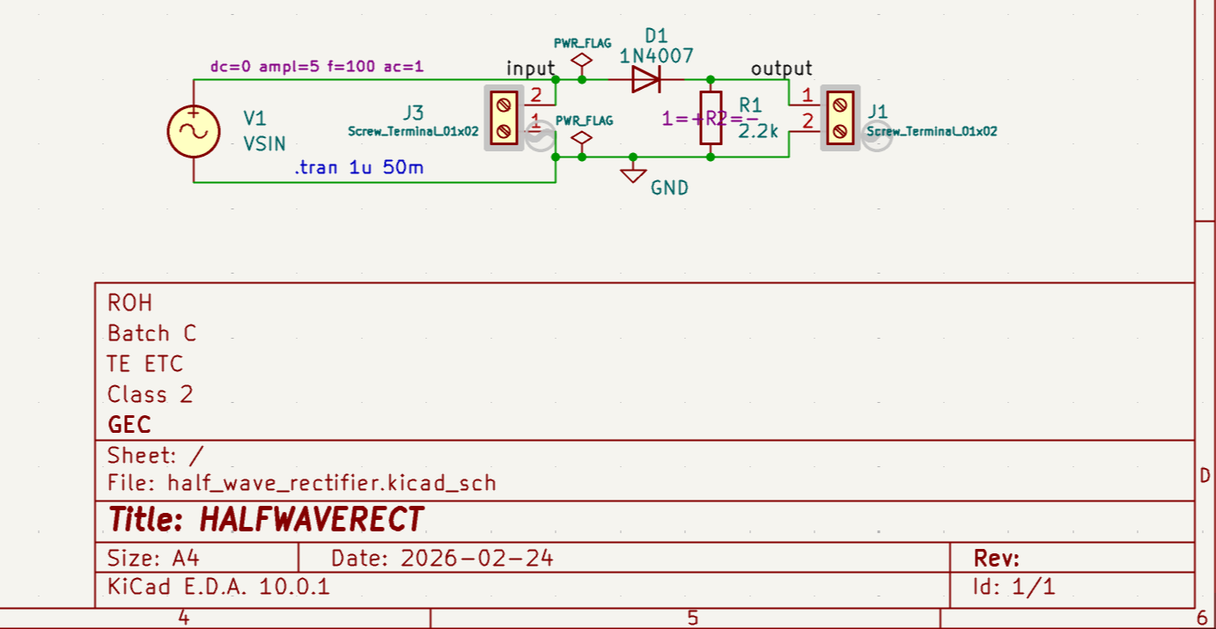
Fig. 3.1 Schematic Layout after ERC
Fig. 3.2 Bill of Materials
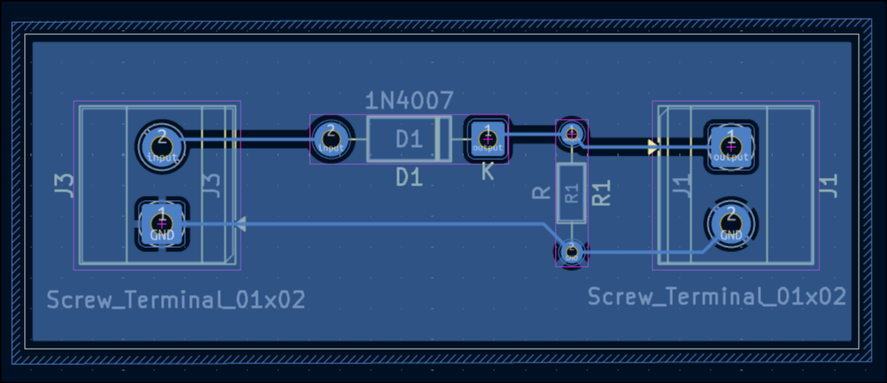
Fig. 3.3 PCB Layout after DRC
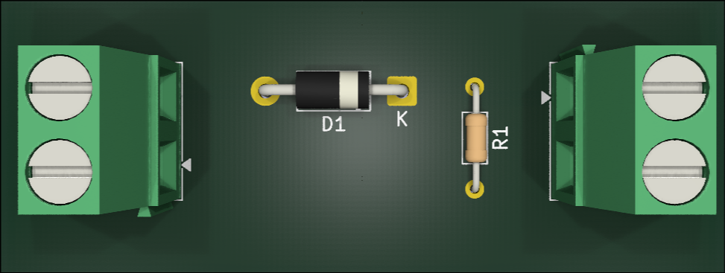
Fig. 3.4 Component-side 3D view
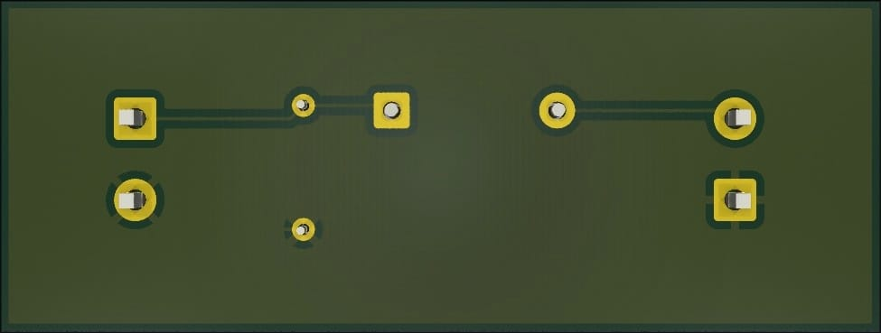
Fig. 3.5 Solder-side 3D view
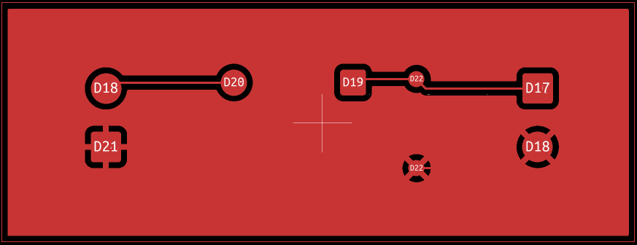
Fig. 3.6 Back Copper Gerber and Excellon Drill Files in Gerber Viewer

Challenges: 1) One of the main challenges I encountered was understanding the ERC rules and what was expected of me, particularly the phrase “Output is not driven by inputs.” Eventually, I realized that I needed to assign PWR_FLAGS to both the input sources and the ground (GND), since GND is equivalent to a 0V voltage source.

2) PCB design was a completely new experience for me until I discovered that KiCAD automatically displays the connections and paths available, allowing me to choose the shortest route.

Conclusion:
- PCB Designing Process was studied and practiced.
- The Schematic and PCB layout was designed and verified with ERC and DRC.

